**Exercise 4.**

Adding new parts to libraries.

Table of Contents

List of Figures 1

Abstract 3

Part 1: Adding a model to the standard library 4

Part 2: Adding a library file, editing a symbol 16

Part 3: Adding operational amplifiers 18

Part 4: Homework 19

# List of Figures

Figure 1 Bipolar transistors BC107A, BC211 and BC313. 4

Figure 2 Transistor Amplifier Schema. 4

Figure 3 Plot Characteristic 4

Figure 4 AC Plot Characteristic. 5

Figure 5 AC Plot Characteristic. 5

Figure 6 Modified circuit. 6

Figure 7 Modified Circuit Plot Characteristic 6

Figure 8 Gain value 6

Figure 9 Capacitance Check. 7

Figure 10 Plot characteristic with Capacitor Values. 7

Figure 11 New Transistor Circuit. 8

Figure 12 New Transistor Circuit Plot Characteristic. 8

Figure 13 New Transistor Resistance Change. 8

Figure 14 Resistances in AC analysis. 9

Figure 15 Two resistances comparison. 9

Figure 16 Modified Circuit for capacitance check. 10

Figure 17 AC analysis. 10

Figure 18 Plot Characteristic. 10

Figure 19 Schematic diagram of a power amplifier with complementary transistors. 11

Figure 20 Class A & B Transistor Based Amps. 12

Figure 21 Plot 2v. 12

Figure 22 Plot 10v. 12

Figure 23 Modified Circuit 13

Figure 24 Output plot 13

Figure 25 Higher values .1 .5 1 2 3 4 13

Figure 26 TDH Good. 14

Figure 27 TDH Bad. 14

Figure 28 MAX acceptable TDH value. 14

Figure 29 Schematic diagram of an amplifier with a field effect transistor. 15

Figure 30 Run simulation. 15

Figure 31 Plot characteristics. 15

Figure 32 Thyristor Symbol. 16

Figure 33 Diagram of a thyristor circuit. 16

Figure 34 thyristor circuit. 17

Figure 35 Schematic diagram of the circuit with an operational amplifier 18

Figure 36 Plot Characteristic. 18

Figure 37 3db 18

Figure 38 Symbol creation 19

Figure 39 New circuit 19

Figure 40 Output 19

Figure 41 New .lib 20

Figure 42 Output 20

# Abstract

The aims of this laboratory exercise were learning how to add new elements to element libraries in LTspice.

# Part 1: Adding a model to the standard library

To begin the exercise I have backed up the data file that I’ve previously had in the presented directory location. Then with use of correct searches I have found the text formatted Spice models of bipolar transistors BC107A, BC211 and BC313, which have been pasted into the standard.bjt library at the very end of the list. Please see figure below presenting this.

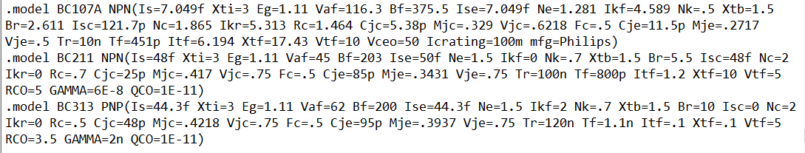

Figure 1 Bipolar transistors BC107A, BC211 and BC313.

Next step of the experiment was to draw a new schema of a transistor-based amplifier, please see figure below presenting this.

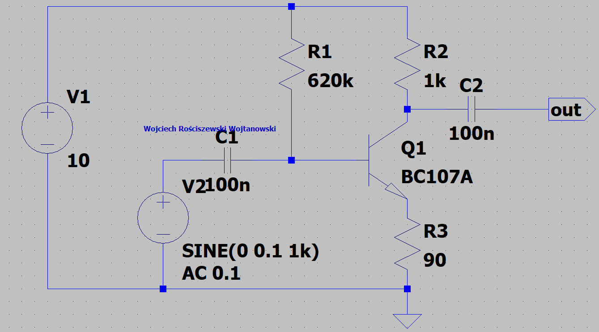

Figure 2 Transistor Amplifier Schema.

Upon running the simulation in the transient mode analysis, the following effects are visible. Please find the green signal being the output signal whilst the blue being the AC wave.

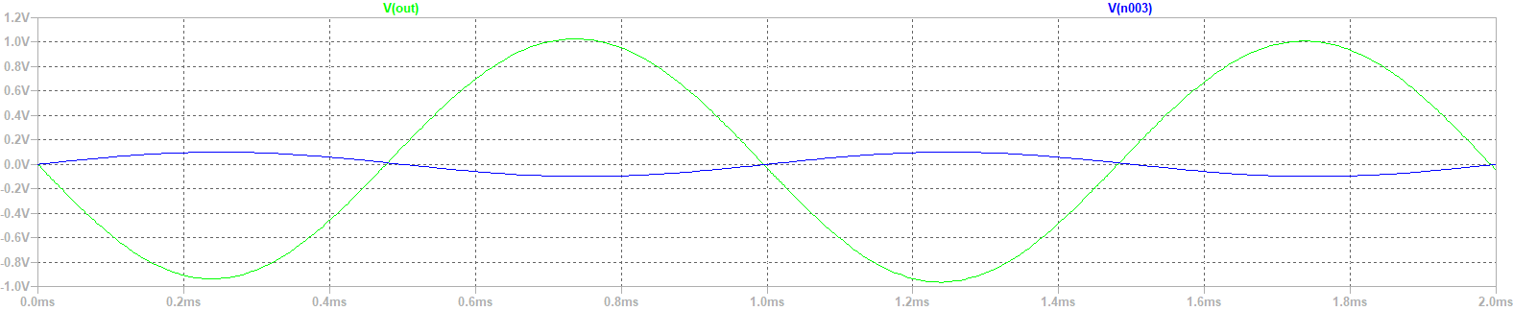

Figure 3 Plot Characteristic

We see the ideal sinus and a sinus wave on output. The signal isn’t right as we don’t have the correct shape of the signal as it seems that it is cut off. The model of the transistor is correct, model whilst copying of parameters its ok. However, there main cause of this is just the circuit.

Now we want to make an AC analysis so we change the SPICE directives by removing and adding the “;” in the correct directives. We use decade, 100 points, start from 1Hz to 1mHz! Since this is a band pass and we have no idea what the values will be we just select a wide area of values from which we can safely choose our values.

In the below please see the following output of the AC analysis of our circuit scheme from the previous figure.

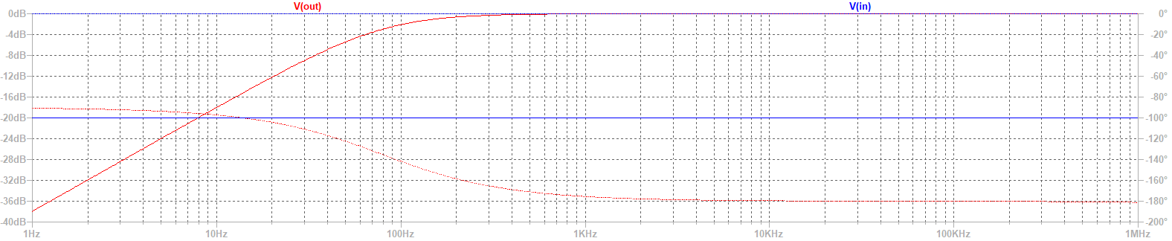

Figure 4 AC Plot Characteristic.

From the figure above we see a middle band pass filter we see this between 1Hz and for example 100Hz, these are our limited values in our circuit. Above 100Hz and more till 1mHz we have 0dB. So we can change the analysis to a different value, for example we can do 100mHz. By doing so we see wide area, above 10mHz the amplifier starts to amplify less, using cursors the lower frequency and higher frequency can be found (changing the range of the vertical axis).

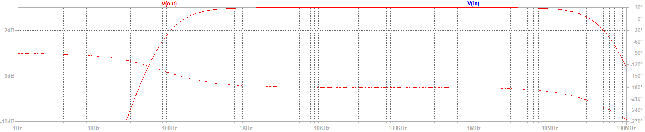

Figure 5 AC Plot Characteristic.

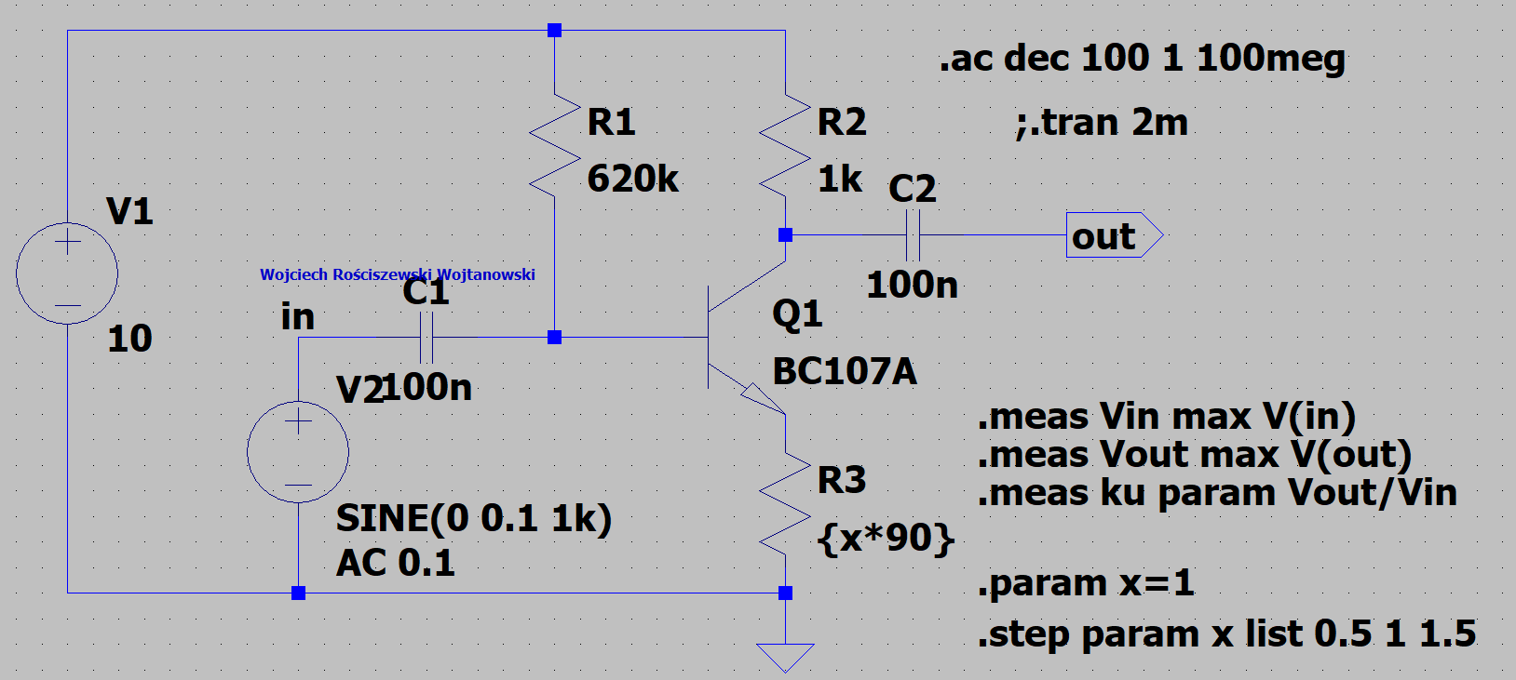

Figure 6 Modified circuit.

I have modified the circuit to show the 50% influence on R3.

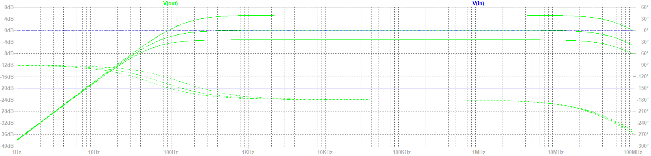

Figure 7 Modified Circuit Plot Characteristic

See that the higher the resistance the lesser the attenuation.

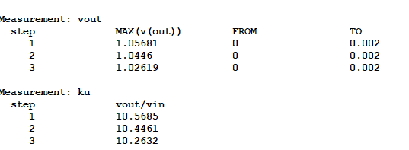

Figure 8 Gain value

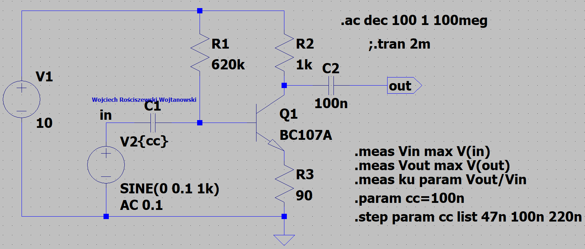

Figure Capacitance Check.

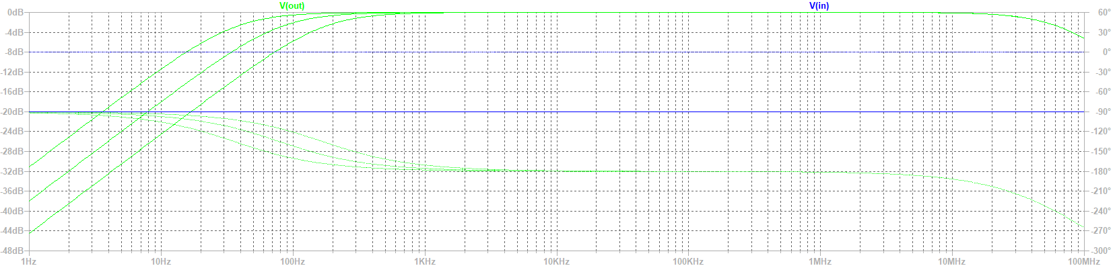

Figure 10 Plot characteristic with Capacitor Values.

For the next part we change the circuit a little, we replace the BC107A transistor to the BC211 transistor.

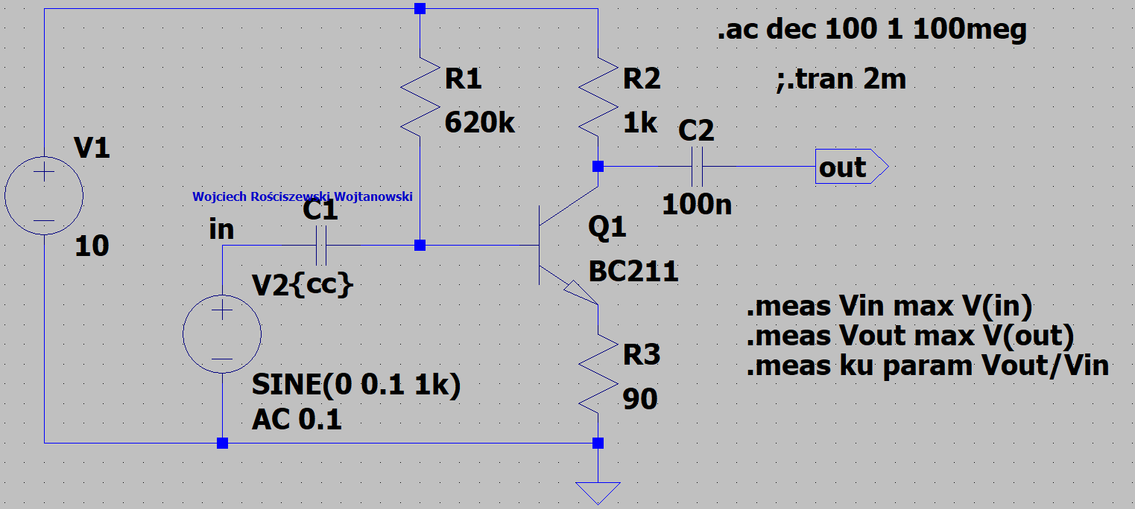

Figure 11 New Transistor Circuit.

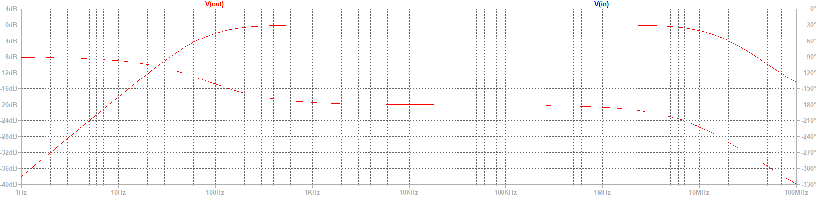

Figure 12 New Transistor Circuit Plot Characteristic.

What do we see? We see that the previous transistor BC107A is a low power transistor whilst the BC211 is a little more powerful but as we see that the range of frequencies are similar so we don’t see any big difference.

We do the similar steps, so we change the resistance and we are able to see the figure below.

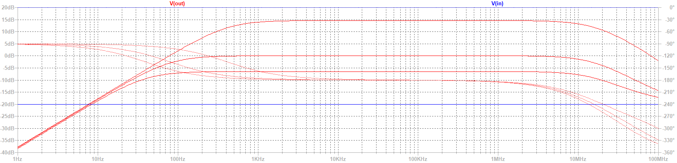

Figure 13 New Transistor Resistance Change.

We see the three values, we used 10, 90 and 200 in the labs. As we see, value of the resistor do not improve nor influence on the bandpass, it had little difference, but it mostly influences the gain so if we run the transient analysis, please see figure below, we can comment on this.

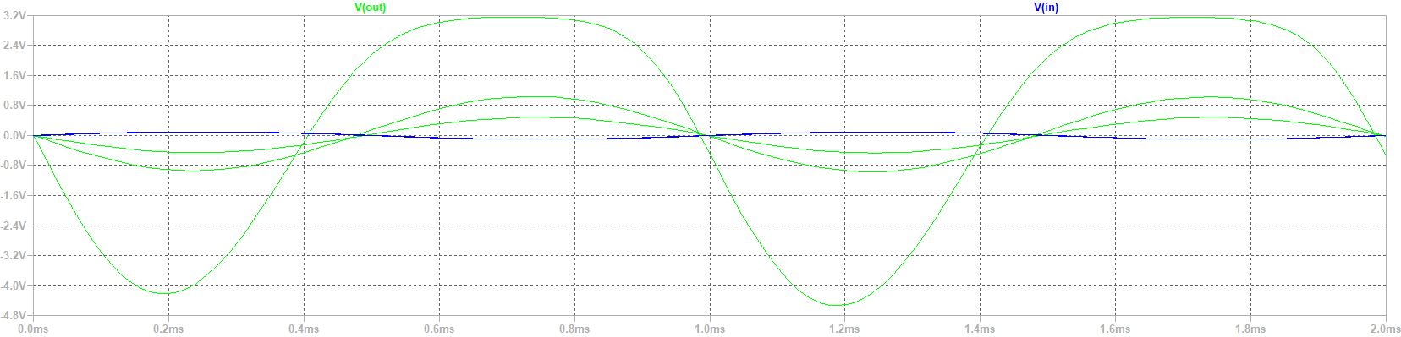

Figure 14 Resistances in AC analysis.

We see the biggest value, it is a sinus match but non ideal so the value is too big, we expect too big gain for this. Ratio to r2 and r3 is the gain so in case of 10 ohms the gain will be 100, this is our biggest gain value. In case of 90 ohms we expect near 10.

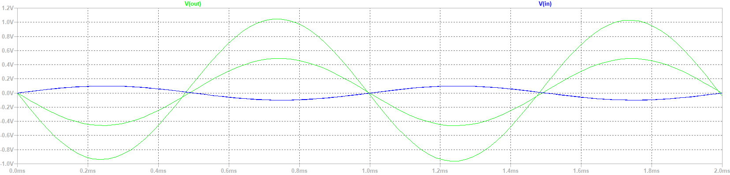

Figure 15 Two resistances comparison.

In figure above I have removed our analyzed resistance, here we see the gain of the biggest sinusoid is around 10 and in this case we have then also 5V gain. Ratio of the resistors R2 and R3 influences on the gain of this circuit!

Now we can also repeat the capacitance sweep parameters similar as to before to see how the capacitance filters out and affects our input. Please find the figures below that approve the mentioned previously.

Please see the modified circuit with changed directives for the next figures.

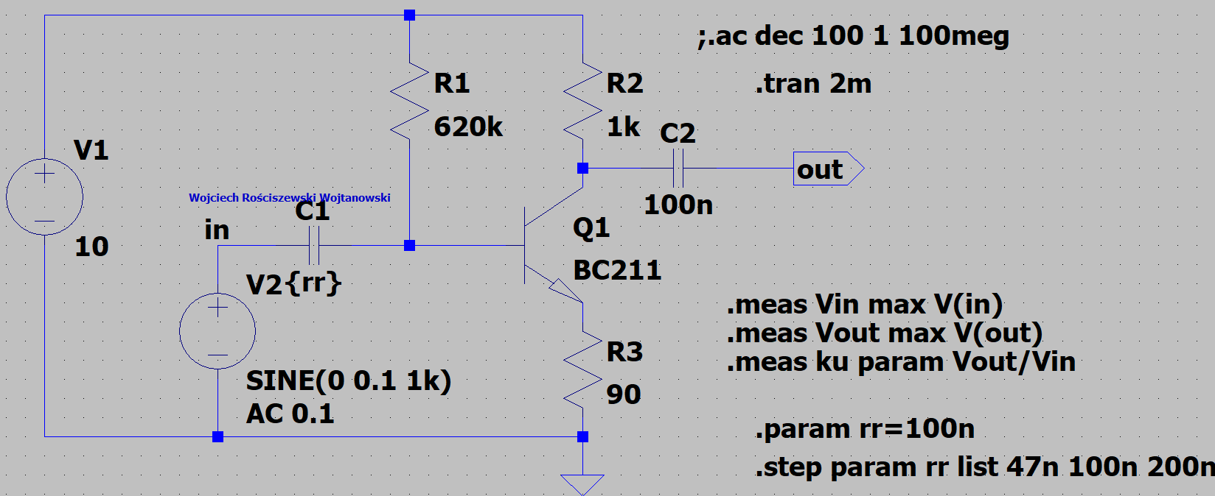

Figure 16 Modified Circuit for capacitance check.

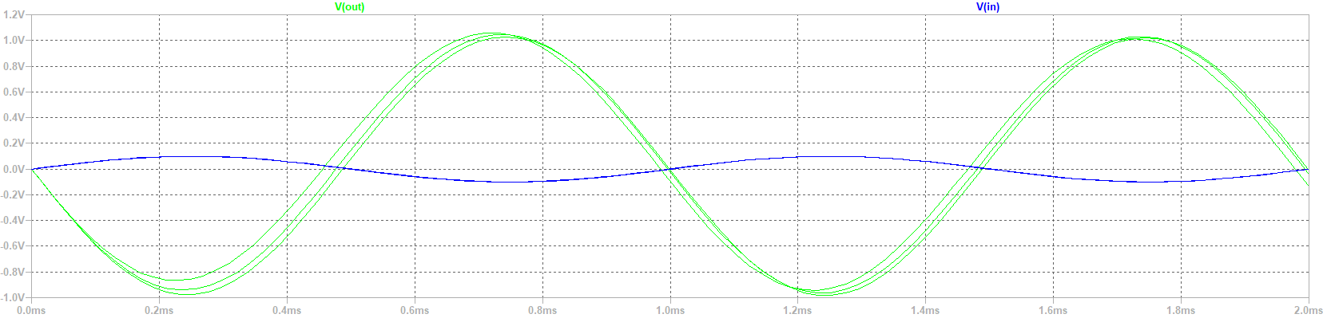

Figure 17 AC analysis.

Here we see that gain is not affected but rather time taken to charge the capacitors is affected, of course this is correct as we change the capacitance values… Below please see the analysis of our circuit to show the bandpass effect so we proceed to the power amplifier circuit.

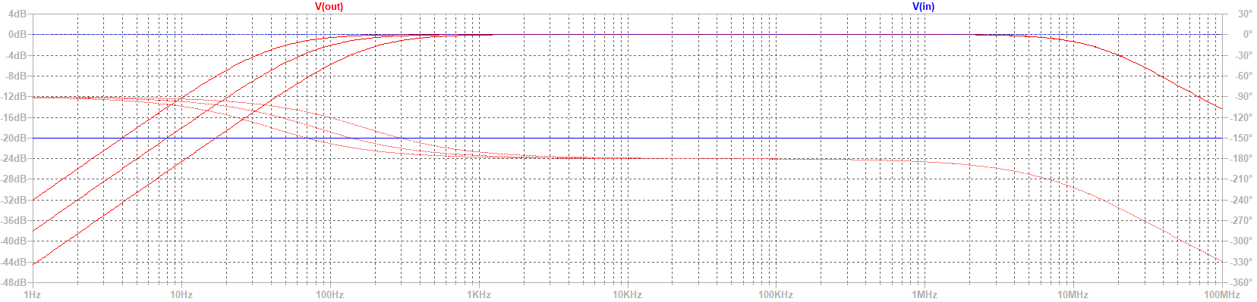

Figure 18 Plot Characteristic.

We see very little change other than the gradient of the rise over frequency, where at lower capacitance we reach the 1V mark faster whilst with more bigger capacitance value we reach the 1V peak value more gradually and slowly. Yet the gradient of the 10Mhz is yet still the same and unchanged as this is where the transistor kick in.

Please see power amplifier circuit below using the BC313, being our complementary transistor.

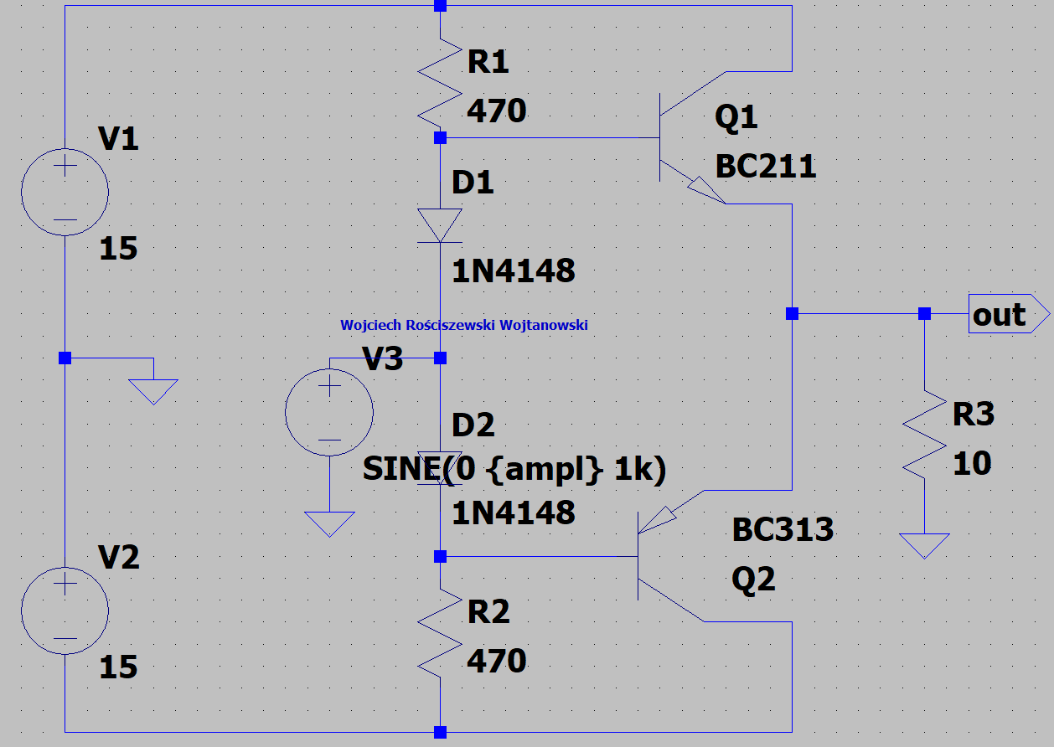

Figure 19 Schematic diagram of a power amplifier with complementary transistors.

Class A and B amplifiers, brief overview... In the below first bipolar transistor is class A, whilst second is class B.

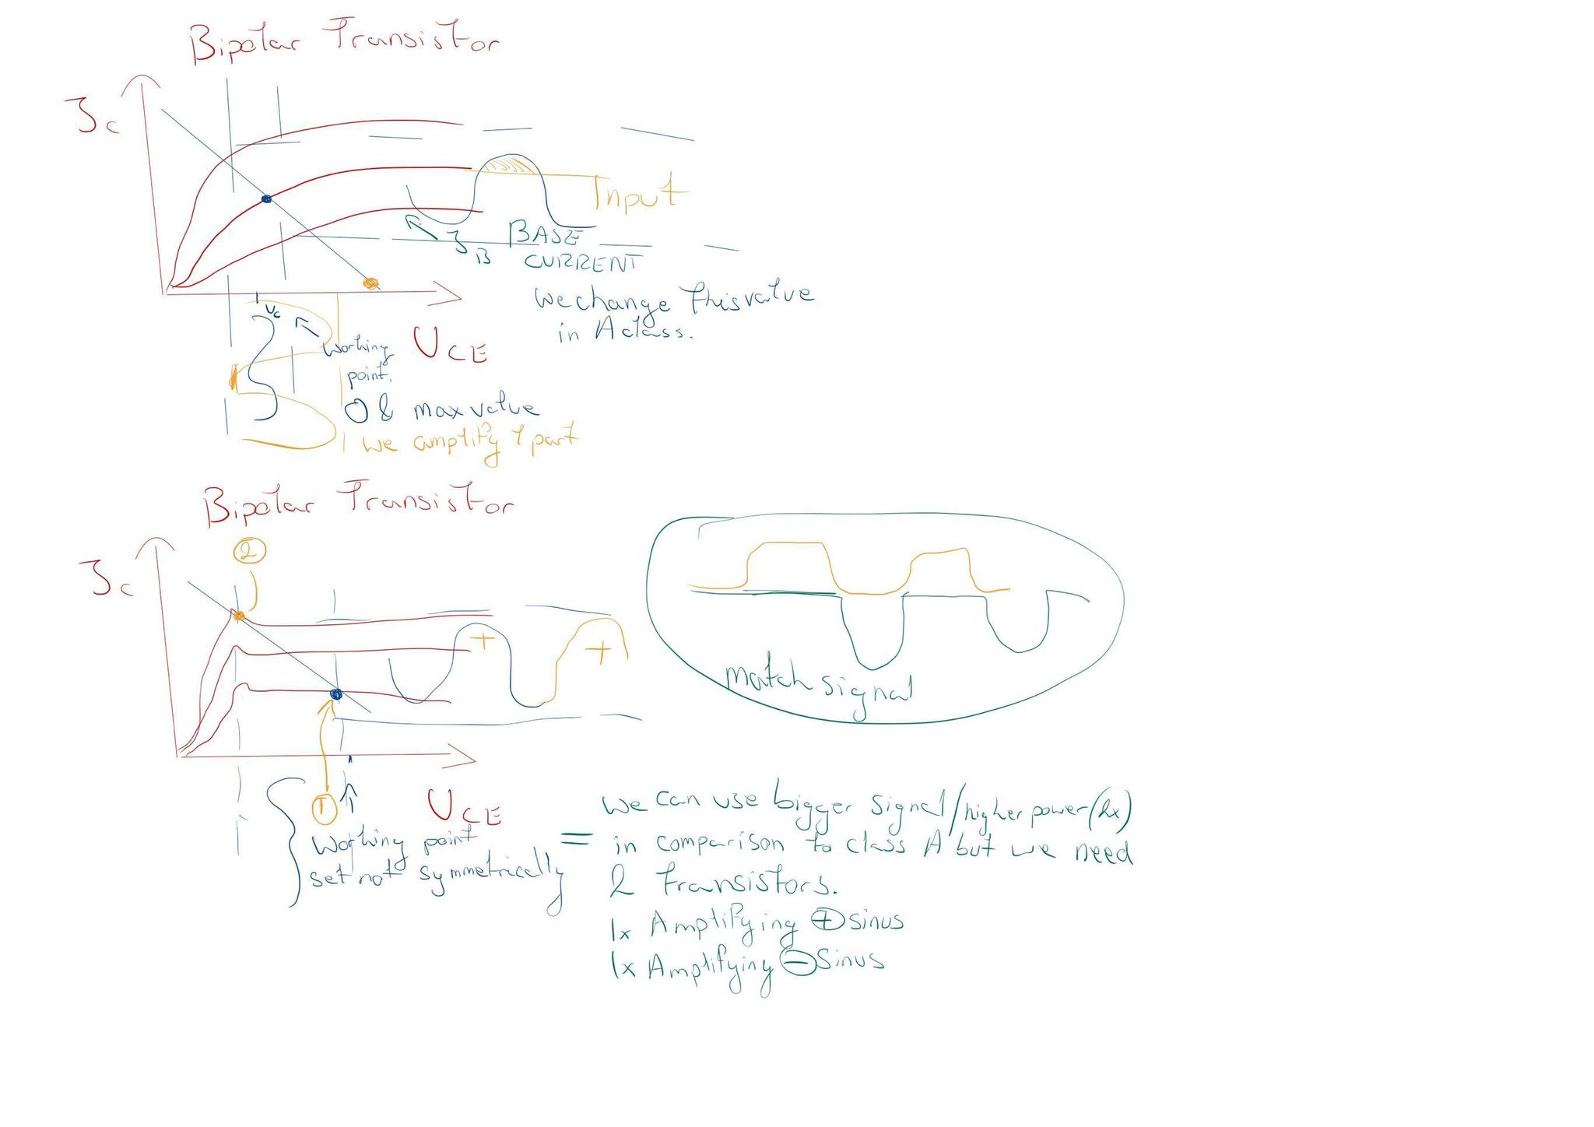

Figure 20 Class A & B Transistor Based Amps.

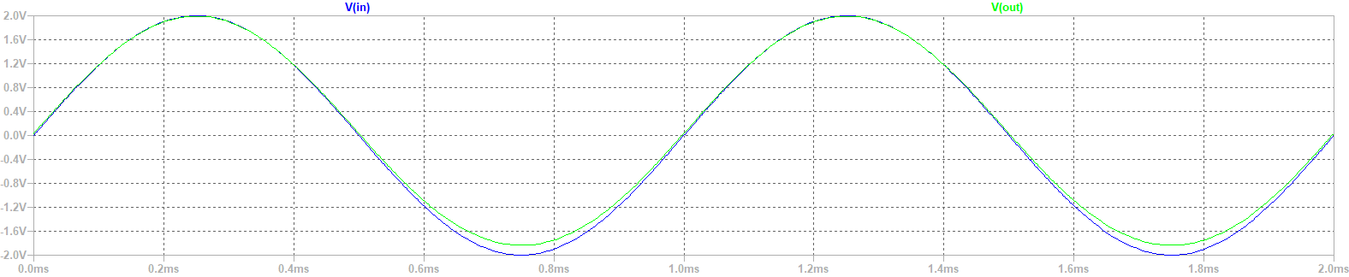

Figure 21 Plot 2v.

From the below we see we have the voltage of 2V, correctly set the AC voltage source V3 to a sinusoid but with 2V. But at 10V the signal is too big and simply at certain amplitudes of frequencies the tops of the signal are being cut off. This is cut off, since the signal is too big for this amplifier.

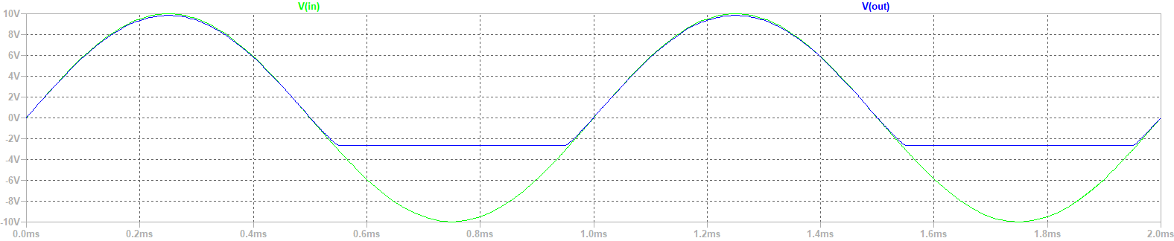

Figure 22 Plot 10v.

Please see blue line being the AC output waveform.

In the below please see the modified circuit with new directives.

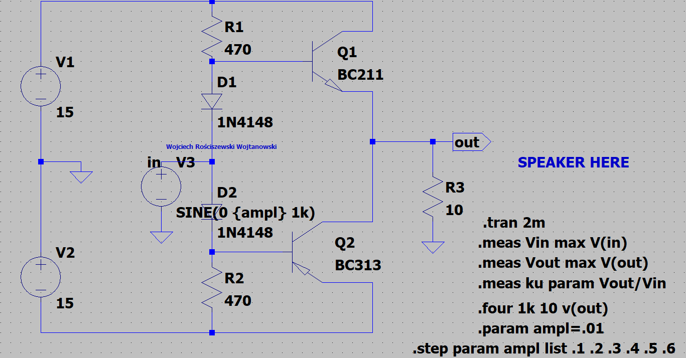

Figure 23 Modified Circuit

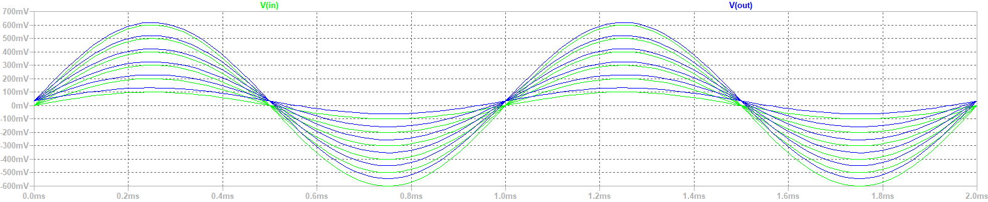

Figure 24 Output plot

In output we see that the signal is quite good, we could change to much higher values, then we will be able to see cut off regions of our amplifier. See figure below. Using the total harmonic distortion we can check which value can be good. Preferably the lower the better, values are in percentages. So 0.1% is very good, 1% isn’t too good.

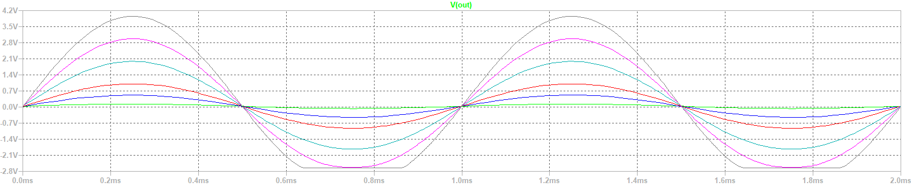

Figure 25 Higher values .1 .5 1 2 3 4

In the below please see the contents indicated in red.

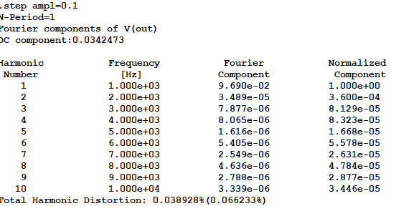

Figure 26 TDH Good.

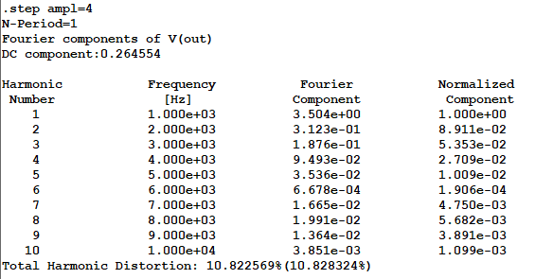

Figure 27 TDH Bad.

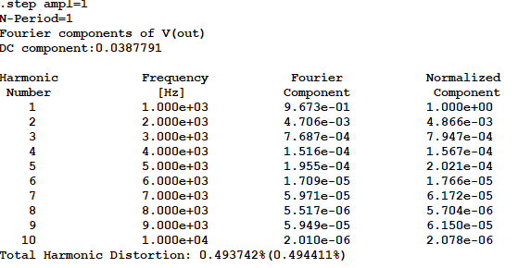

Figure 28 MAX acceptable TDH value.

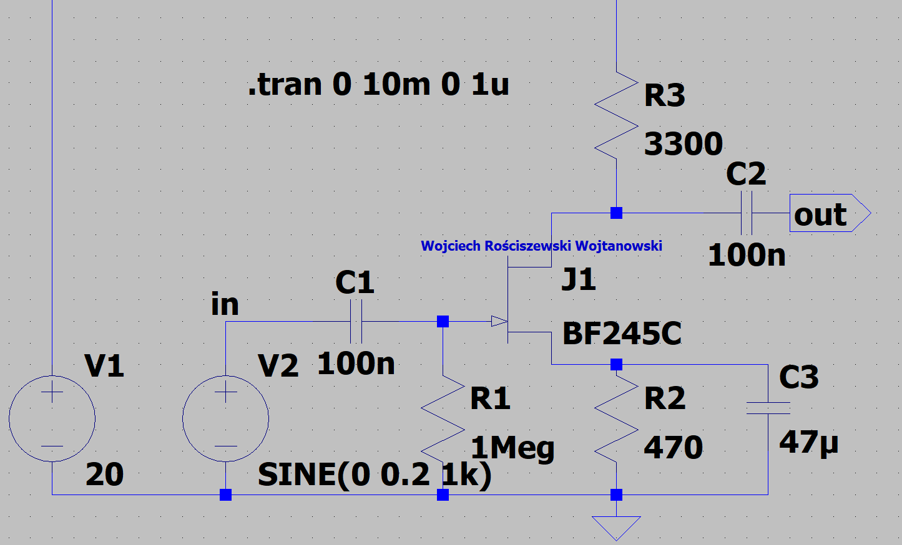

Figure 29 Schematic diagram of an amplifier with a field effect transistor.

Simulation run, please see figure below.

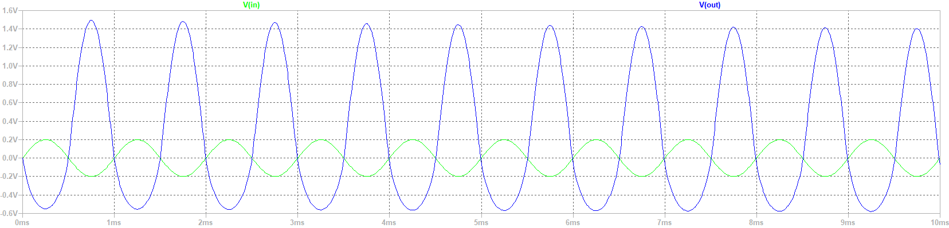

Figure 30 Run simulation.

We now search for the 3db passband gain. Please see below.

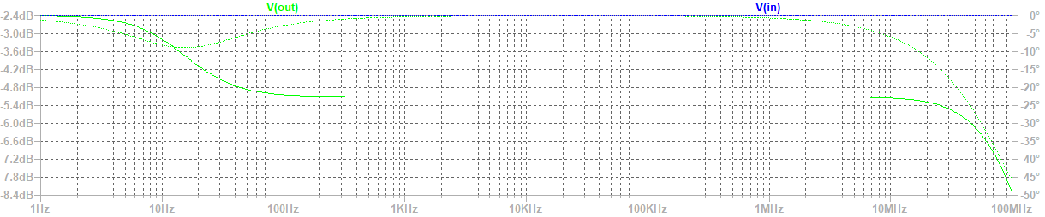

Figure 31 Plot characteristics.

The gain is ku= vout/vin=7.48412, it has been calculated by the .meas directive.

Passband f1=25.6MHz.

# Part 2: Adding a library file, editing a symbol

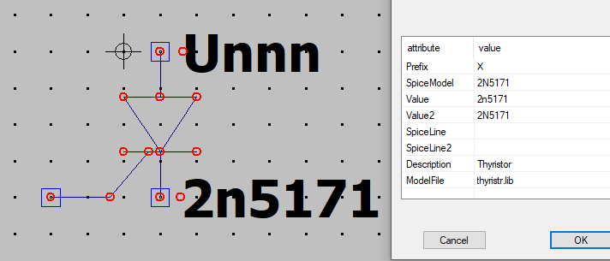

Figure 32 Thyristor Symbol.

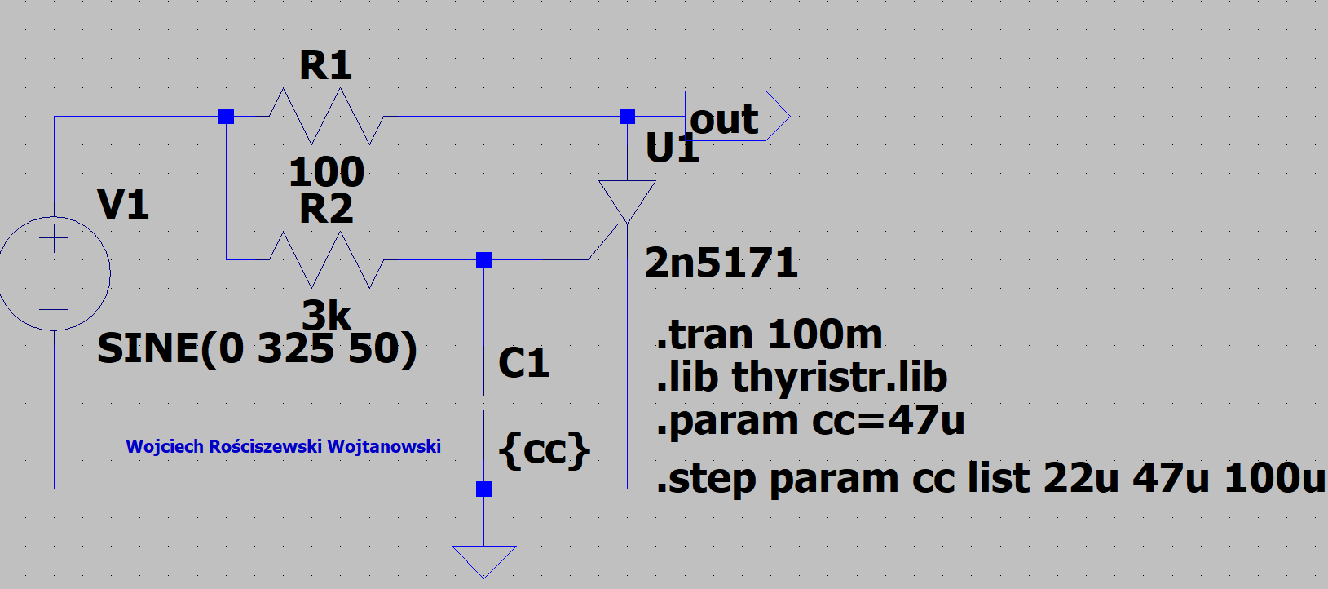

Figure 33 Diagram of a thyristor circuit.

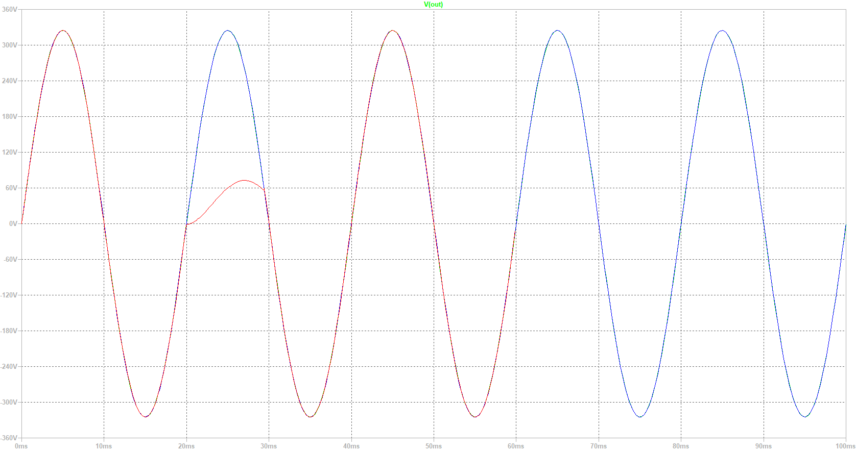

Figure 34 thyristor circuit.

From the perspective we see the circuit is operating successfully.

# Part 3: Adding operational amplifiers

In the below please see the new circuit for the method of adding op amps. Here we use the OPA388 that we have inputted into the LTspice directory.

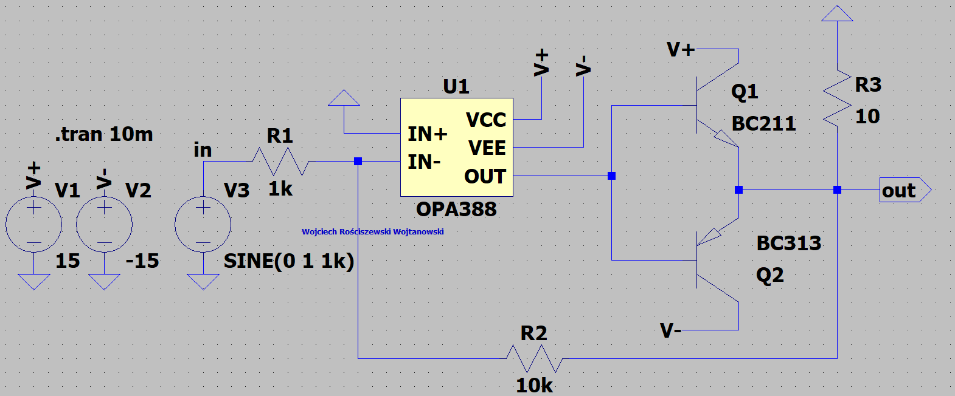

Figure 35 Schematic diagram of the circuit with an operational amplifier

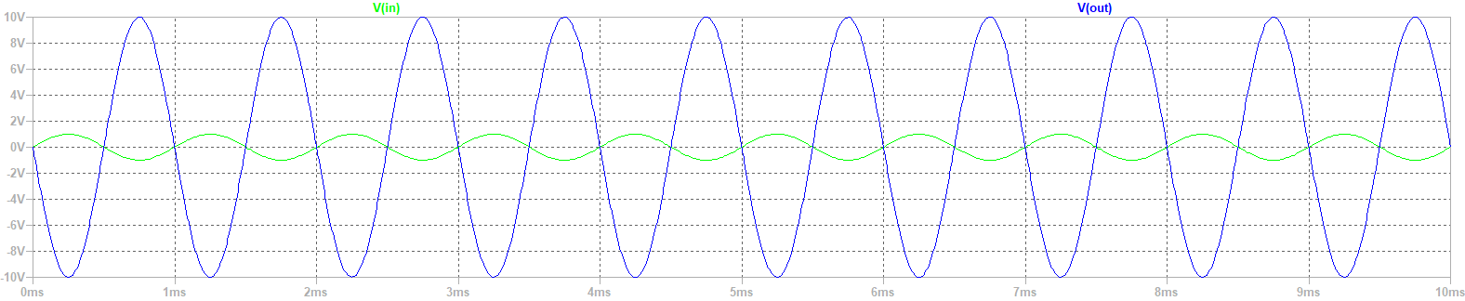

Figure 36 Plot Characteristic.

The gain of our system is equal to.

**vin: MAX(v(in))=0.999991 FROM 0 TO 0.01**

**vout: MAX(v(out))=9.99915 FROM 0 TO 0.01**

**ku: vout/vin=9.99925**

Next please find the enclosed passband of 3dB which is around 6.19KHz.

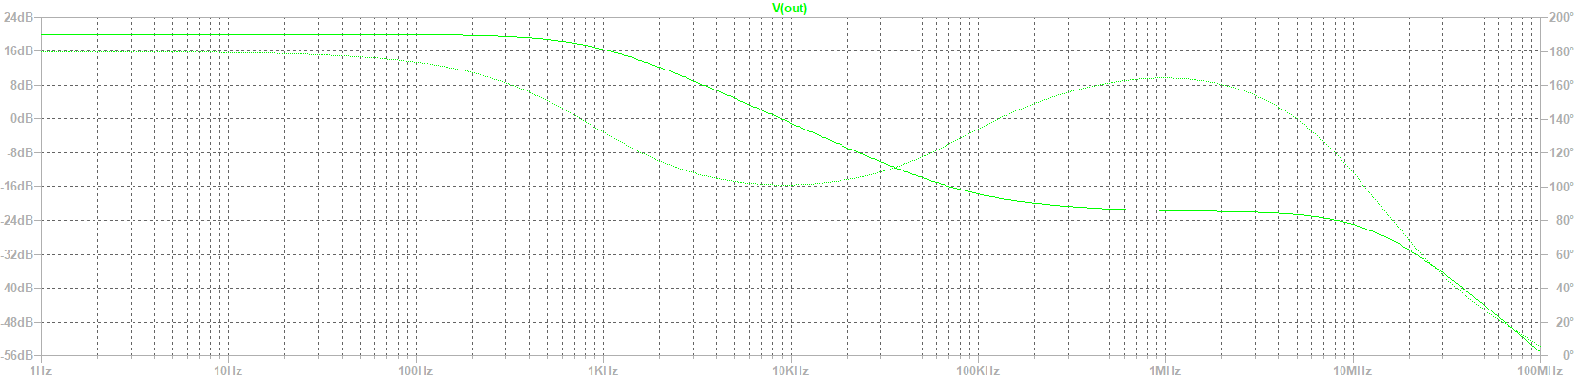

Figure 3db

# Part 4: Homework

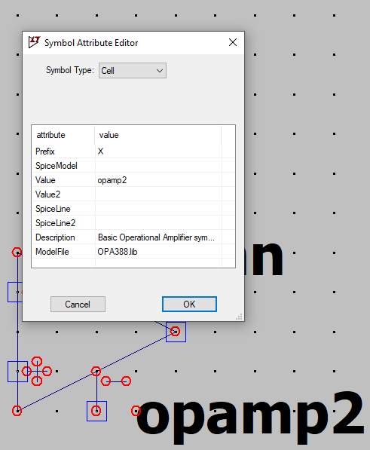

Figure Symbol creation

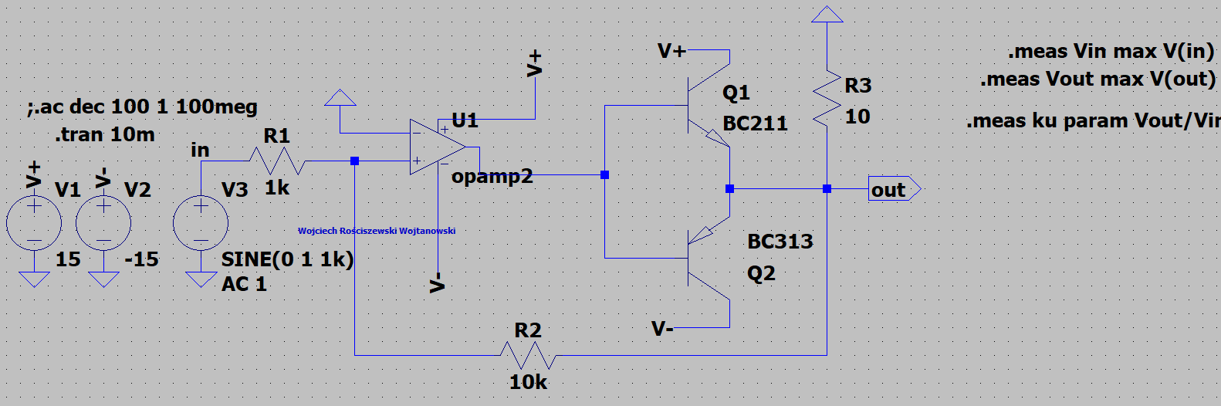

Figure New circuit



Figure 40 Output

As we see circuit is operating correctly.

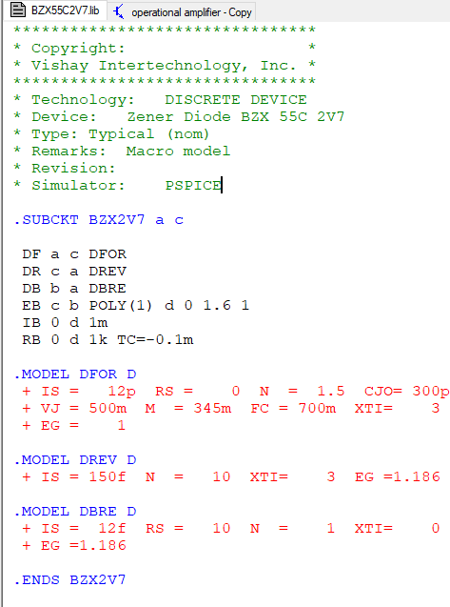

Figure 41 New .lib

Output of the BZX55C2V7

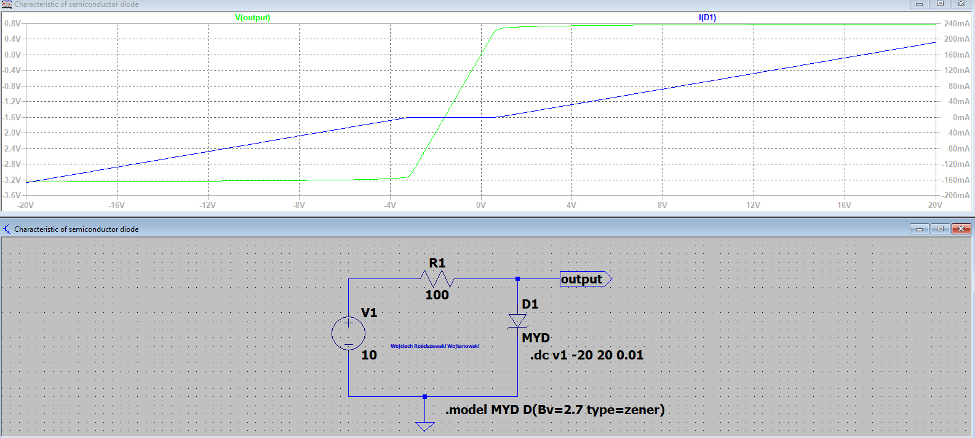

Figure Output